Open Innovation Challenge
Bologna Case

The next 3 buildings were chosen by ACER, the building public company of Bologna as an example of typical buildings in Bologna that should be renovated to reach climate neutrality.

- Via Beroaldo 15, 17, 19 Bologna
Built in 1954. Typical “building in line” made up of 3 stairwells which serve two apartments per each.

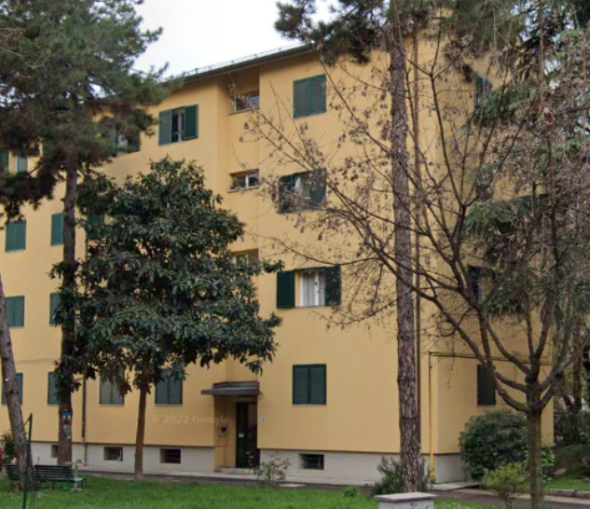

- Via del Lavoro 26, 28, 30 Bologna
Built in 1937, renovated in 1986. Typical “building in line” made up of 3 stairwells which serve two apartments per each.

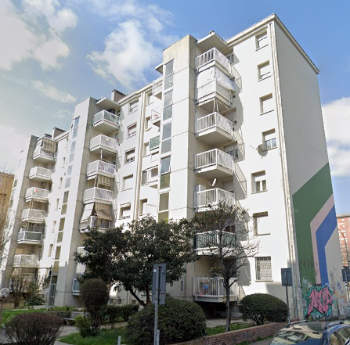

- Via Reiter 17, Bologna
Builded in 1955. Multistorey block condominium building with a single staircase serving two residential units per each.

